|  |
| --- |
| **Exercise 6** |

**Copy this file and open it in Word or some other editor where you can insert images. Be sure to read "How to Copy the Results of a Query" found in Module 2 in Canvas.    This is how you will be answering the following questions.**

1. Write a stored procedure using the premier_products database that will change the price of a part with a given part number. Name your stored procedure *Change_Price*. For example, how would you use this stored procedure to change the price of part AT94 to $26.95 (Change_Price(‘AT94’, 26.95))?
   1. Display the contents of the stored procedure here:

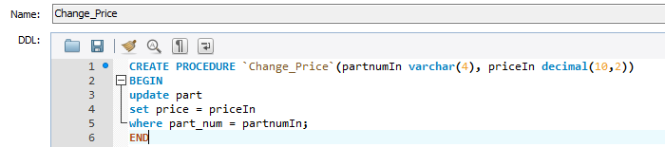

* 1. Run your procedure. What construct did you use to run this query?

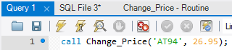

* 1. Insert the results of running the stored procedure here:

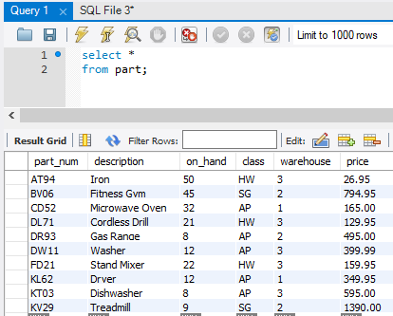

1. Define a view named TopLevelCust that consists of the number, name, address, balance and credit_limit of all customers with credit limits that are greater than or equal to $5,000. Address is defined as street, city, state and zip. Concatenate these into one field named Address.
   1. Type in your view construct here:

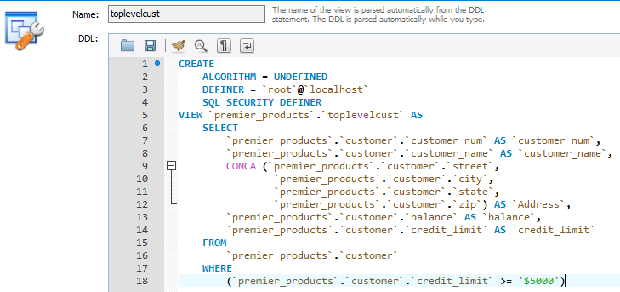

* 1. Write a query to retrieve the number and name of all customers in the TopLevelCust view. Insert your query and results here. *Be sure all columns show*

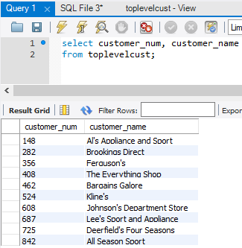

* 1. Write a query to retrieve the number and name of all customers in the TopLevelCust view with balances that exceed their credit limits. Insert your query and results here.

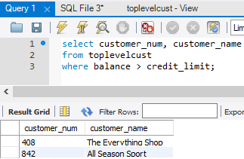

3. Define a view named PartOrder. It consists of the part number, description, price, order number, order date, number ordered and quoted price for all order lines currently on file.

1. Type in your view construct here:

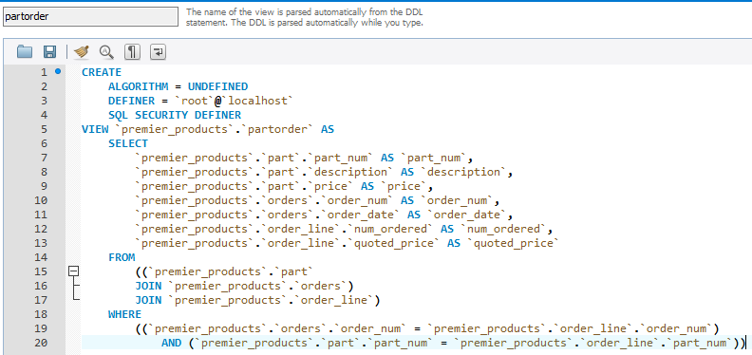

b. Write a query to display the contents of the PartOrder view. Insert your query and results here.

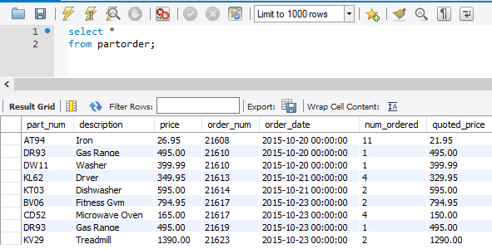

c. Write a query to retrieve the part number, description, order number, and quoted price for all orders in the PartOrder view for parts with quoted prices that exceed $100. Insert your query and results here.

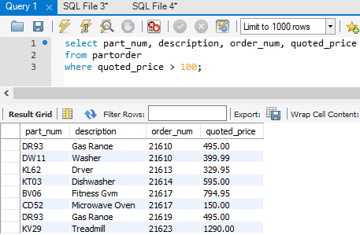

4. Orders have picked up due to the upcoming holiday sales rush. Update the inventory with the following activities. Create one transaction that will insert/update/delete the following information:

* A shipment of 5 gas ranges has arrived. Add to inventory.
* Due to recalls, 3 of the stand mixers have been returned to the manufacturer. Deduct these from the inventory.
* A new product has been added to the inventory. Part number: CN16, Description: Refrigerator, On hand: 10, Class: AP, Warehouse: 2, Price: 1495.00

1. Display the contents of the transaction you typed in. Insert your snip here.

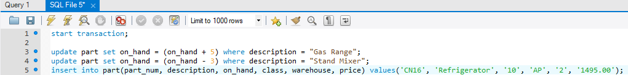

1. Display the contents of the part table. Be sure all rows display and show the updates added. Insert your snip here.

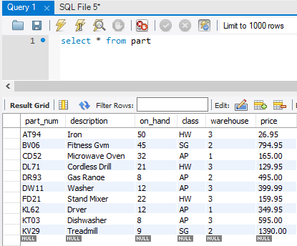

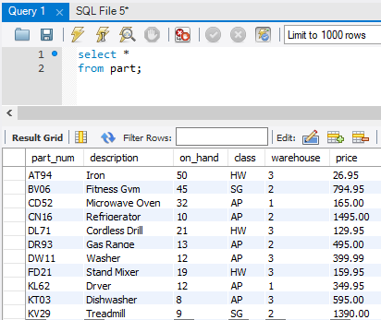

Using the Henry Books database:

5. Create a stored procedure named *branchInventory* that will display the books available by branch. Display the book code, book title, publisher code, book type, price, paperback indicator, and the inventory on hand.

1. Display the contents of the stored procedure here:

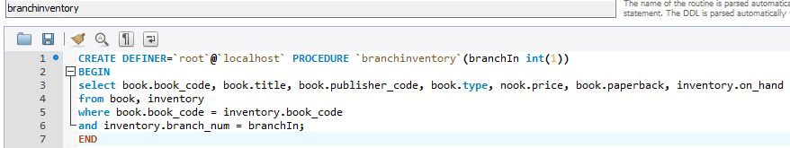

1. Run your procedure for branch 1. What construct did you use to run this query?

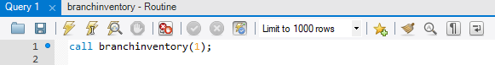

1. Insert the results of running the stored procedure here:

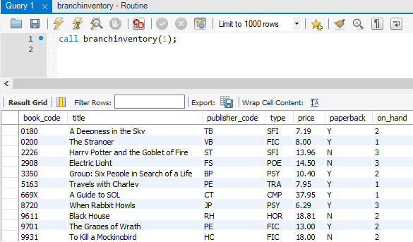

6. Create a stored procedure named *booksByPublisher* that will return the books by a given publisher and type. Display the book code, title, type, price, paperback status, publisher name, and publisher city.

1. Display the contents of your stored procedure here:

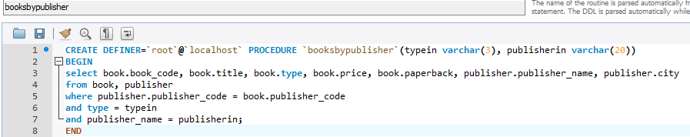

1. Run your procedure for fiction books published by Penguin Books. What construct did you use to run this query?

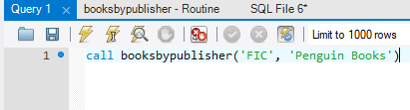

1. Display the results of running the stored procedure here:

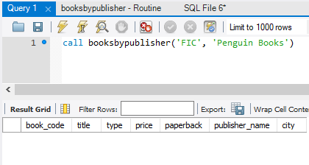

7. A transaction needs to be created for the activities this day. Create one transaction that will insert/update/delete the following information:

* Add the new book 8306 written by author 26 to the wrote table. Sequence is 1.
* Update the name of publisher code JT to ‘J.P. Tarcher’
* Add book code 8306 to inventory. This book will be at branch 3 with 2 copies.

1. Display the contents of the transaction you typed in. Insert your snip here.

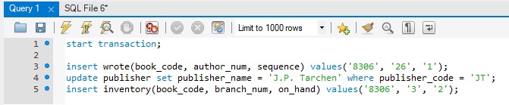

1. Display the contents of the new row in the wrote table. Insert your snip here.

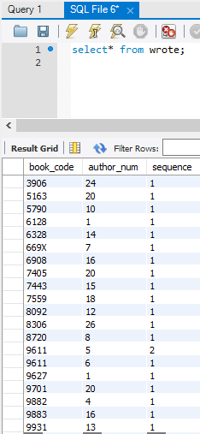

1. Display the contents of the new row in the inventory table. Insert your snip here.

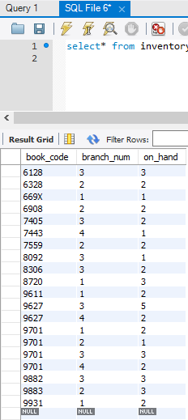

1. Display the contents of the updated row in the publisher table. Insert your snip here.

